Catherine Blackburn: NEW AGE WARRIORS
February 1 – May 5, 2019
Curated by Jesse Campbell; Organized by the Mann Art Gallery
in partnership with MJM&AG, Neutral Ground Artist-Run Centre,
Chapel Gallery and the Art Gallery of Swift Current

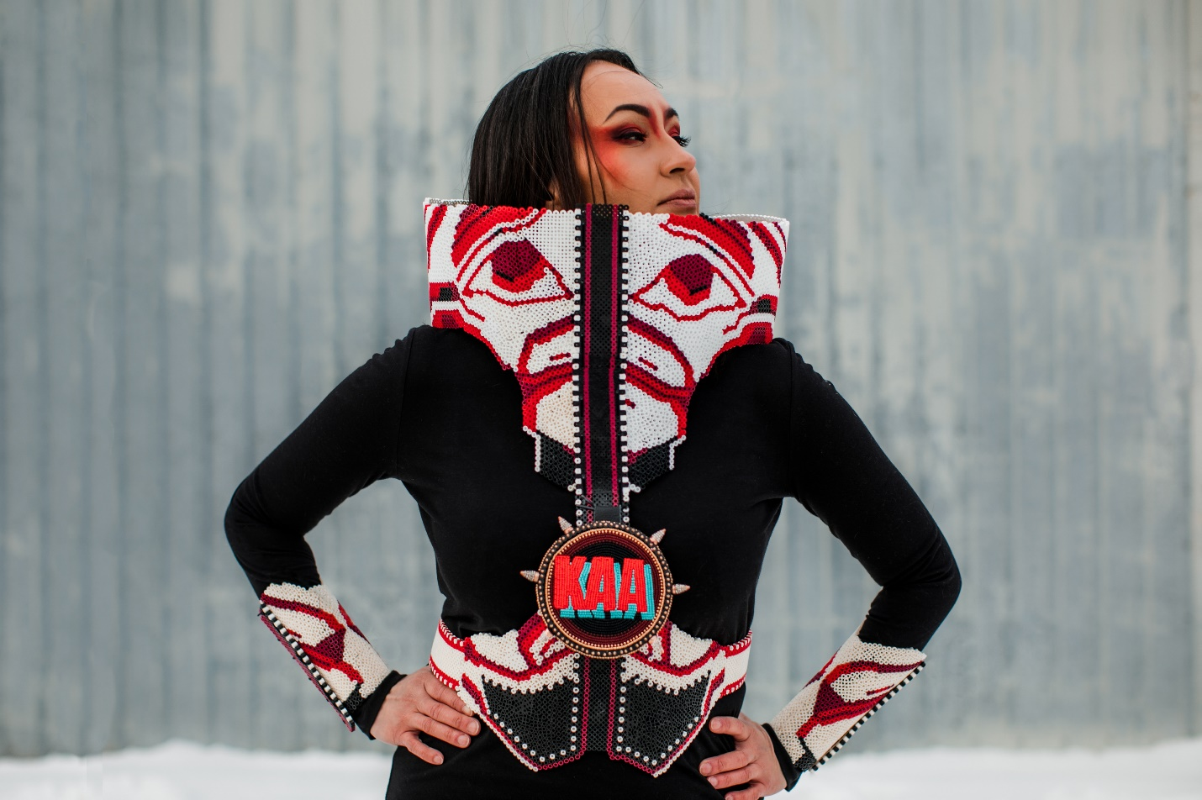
Catherine Blackburn, The Churchill Challenger, Inkjet on dibond, 4. X 5’, 2018
Catherine Blackburn, of Dene and European roots, is part of a new generation of contemporary beaders on the prairies who has made a name for herself nationally and internationally in the past few years. Much of her earlier work, including 'But there's No Scar, Our Mother(s) Tongue, and Tell Me the Truth grapples with themes of loss and survivance, and similar concepts underpin this exhibition. Yet in many ways, this is a series that defies the spaces she has most commonly treaded. Presenting photography and beaded works together, New Age Warriors opens conversations about Indigenous innovation, ways to live on the land in the twenty-first century, and how love serves as a mighty force. With gear designed from plastic beads, Blackburn draws from the past and present to shape notions about an imagined future - a future filled with strong Indigenous women in protective Armour battling stereotypes and facing colonialism by channeling the power of love.
-Dr. Carmen Robertson (quote from the exhibition catalogue, New Age Warriors, 2018)

